A Sensorized Glove for Therapist Skill Performance Assessment During Neck Manipulation*

Abelardo Escoto, Ana Luisa Trejos

Faculty of Engineering

Western University

London, ON, Canada

David M. Walton, Jackie Sadi

School of Physical Therapy

Western University

London, ON, Canada

*Abstract*—Skills performance assessment in physical therapy is mainly evaluated by observational means from an expert. Recent advancements in technology enable the creation of smart instrumentation that can aid trainees and evaluators during the learning and evaluation process. Towards this goal, this paper presents the design and development of a sensorized glove for measuring movement and interaction forces of the hand during neck manipulation. The glove can measure forces with an error of less than 1 Newton and is capable of detecting motion and forces during manual rehabilitation maneuvers such as high-velocity, low amplitude neck manipulation. Future work will focus on further validation of the glove, creating a wireless prototype, and exploring the glove’s value for training and practice.

Keywords—sensorized glove; neck manipulation; therapist skill; performance assessment; force sensing.

# Introduction

Acquisition and evaluation of manual skills training for physical therapists has not changed dramatically over at least the past 40 years. Learners observe and attempt to mimic the maneuvers of experts, who provide (often inconsistent) external feedback to facilitate skill acquisition. Evaluation of proficiency is most often conducted through purely observational means, relying on raters to qualitatively discriminate between appropriate or inappropriate parameters such as speed, force, and amplitude whilst an examinee performs manual or manipulative ‘thrust’ techniques on a healthy subject. This approach may be acceptable for low-risk maneuvers, but inappropriately performed neck manipulation is recognized as a possible trigger for potentially catastrophic outcomes, including stroke or death [1]. The discordance between the current methods for evaluating proficiency and the potential risks of inadequate skill in application seems to be a critical gap in training of rehabilitative or other health professionals. There is a need to address this gap by developing smart instrumentation that can help learners and raters with learning and evaluation.

## Prior Art

Motion tracking and performance quantification have become ubiquitous in the form of smartphones, watches, and other consumer-oriented wearable devices. This is attributable to recent reductions in cost and size of inertial measurement units (IMUs) and the advent of powerful wireless computing devices that can provide real-time capture and interpretable graphic presentation of many simultaneous data sources. Low cost and low power consumption coupled with high precision have allowed these microsensor units to be employed to great effect in both the consumer and academic arenas with field-changing results. In the consumer space, innovation is occurring in novel fields that now provide real-time quantified feedback to athletes, trainers, labourers, computer and medical professionals. Examples in the athletic space include the Sensoria Smart Sock (Sensoria Fitness Inc., Redmond, WA, USA) and the Motion-capture Smart Shirt (ProjectPOLE, New York, NY, USA). The computer interaction field has led with new human–computer interaction devices including the MYO Armband (Thalmic Labs Inc., Kitchener, ON, Canada) that integrates IMUs and surface electromyography (EMG) sensors in a small wearable armband for effortless interaction. In the healthcare field, IMUs, EMG and sensitive flexible materials have been employed for several applications, such as low back pain rehabilitation (DorsAvi Inc., London, England).

This work was supported by the Natural Sciences and Engineering Research Council (NSERC) of Canada under grant RGPIN-2014-03815, and by the Ontario Ministry of Economic Development, Trade and Employment and the Ontario Ministry of Research and Innovation through the Early Researcher Award (A.L. Trejos).

Abelardo Escoto is with the Department of Electrical and Computer Engineering at Western University (UWO) (email: aescoto2@uwo.ca). Dr. David Walton is with the School of Physical Therapy at UWO (email: dwalton5@uwo.ca). Jackie Sadi is with the School of Physical Therapy at UWO (email: jsadi2@uwo.ca). Dr. Ana Luisa Trejos is with the Department of Electrical and Computer Engineering at UWO (telephone: 519-661-2111 ext. 89281; fax: 519-663-8401; email: atrejos@uwo.ca),

Despite these advances in technology, to the best of our knowledge, an instrumented glove that can provide quantitative, objective, real-time visual feedback to learners and raters for skills performance assessment during neck manipulation by manual therapists is still missing. Prior attempts to quantify manual therapy performance have included an instrumented treatment table [2] and the creation of a non-biofidelic instrumented ‘dummy’ spinal column [3]. To fill the existing gap, this paper presents a sensorized glove capable of measuring the contact forces and movement accelerations present during manual neck manipulation applied by clinicians, as a first attempt to sensorize the operator rather than the target surfaces. The following section presents the glove design, development, and evaluation.

# Sensorized Glove Development

## Glove Design

A sensorized glove for teaching neck rehabilitation has been designed and developed (Fig. 1). The purpose of the glove is to measure the forces and accelerations applied by the hand to the neck during manual neck rehabilitation maneuvers. The collected information can be used to facilitate skill acquisition through accurate quantification and feedback of key performance metrics for manual therapy (e.g., physiotherapy, chiropractic) trainees. The sensorized glove components are as follows:

* The glove material is composed of two layers, the outer one is used for sensor installation and the inner one for sensor protection. The fabric of the outer layer is a cotton-lycra blend, selected due to its elasticity and stretchiness for accommodating the different sensors of the glove. The fabric of the inner layer is cotton, selected for its comfort and sweat absorbing characteristics.
* Nineteen force sensitive resistors ((FSR) FSR 400, FSR 400 Short, and FSR 402, Interlink Electronics Westlake Village, CA, USA) are used for measuring the force applied by the hand. The smaller sensors were placed on the palm and each of the phalanges as shown in Fig. 2. The distal phalanx of the thumb and the right side of the palmar surface were sensorized with the FSR 402 sensors, which have a larger surface area.
* One accelerometer (MPU-6050, InvenSense, San Jose, CA, USA) mounted on the back of the hand is used for measuring hand acceleration.
* An electronic platform (Arduino Mega, Somerville, MA, USA) is used for handling signal acquisition and computer communication. This platform was chosen as it is easy to use and implement. It provides 16 analog inputs, 54 digital I/O, and it can be powered with the same USB cable used for computer interfacing, eliminating the need of an external power supply. The accelerometer is connected to the SDA and SCL digital inputs, and the FSRs are connected to the analog inputs of the Arduino. It is important to mention that since this Arduino only has 16 analog inputs and the glove has 19 FSRs, the FSR sensors I2, M2, and R3 were not connected in the current prototype. The decision of which sensors to connect was made by an expert Physiotherapist.
* Other electrical components include: flexible electrical wire (NEF26-10546, Cooner Wire, Chatsworth, CA, USA), ribbon cables, breadboard wire, breadboard ribbon connectors (2x8), DB15 connectors, 10 kiloohms resistors, and a breadboard.

## Software Design

Fig. 3 shows the custom software graphical user interface (GUI) developed to visualize the functioning of the sensorized glove. The GUI has a 2D view of the back of the right hand, with different areas representing the 19 FSRs installed on the glove. Each of these areas change colour based on the force measured. The colour scale is displayed on the right side, going from 0 Newtons to the maximum force used during calibration (default value is 10 Newtons). The GUI allows the user to calibrate each of the FSRs (as explained below), and save the force and acceleration data in a .csv file with a sampling rate of 70 Hertz. The GUI also displays the status of the Arduino and the accelerometer and has a log to display important information about the system.

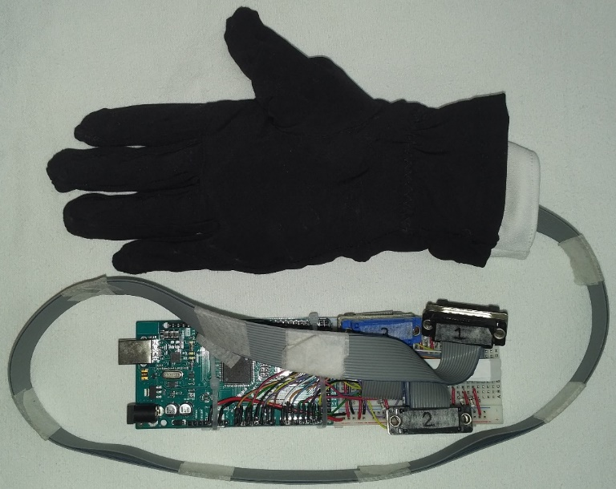

1. Sensorized glove and required electronics.

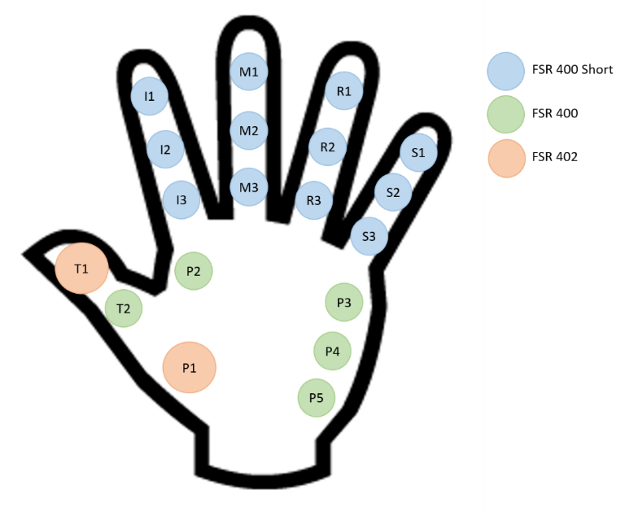

1. Location of the FSR sensors.

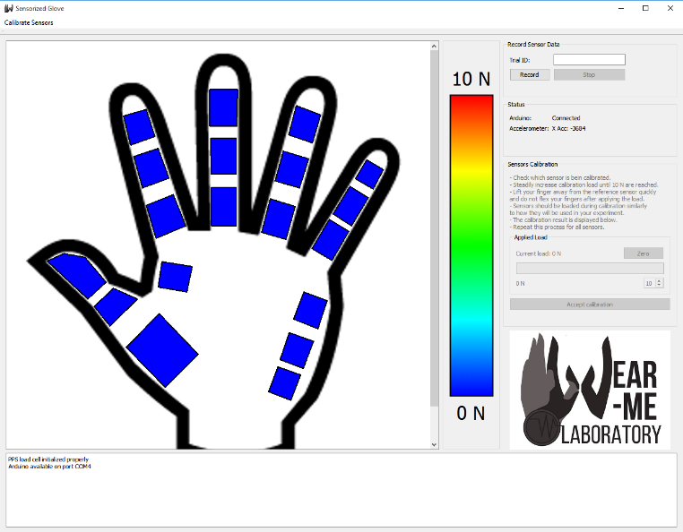

1. Graphical user interface for the sensorized glove.

## Calibration of the FSRs

The FSRs need to be calibrated in order to provide meaningful force measurements. When force or pressure is applied to the sensor, its resistance changes following a linear pattern. Sensor calibration consists of applying known forces to the sensor while recording its corresponding resistance values. These data are used afterwards for calculating the linear parameters that relate resistance and force, by using linear regression algorithms. For the developed glove, in order to calibrate the FSRs a load cell (FRS166, Pressure Profile Systems, Los Angeles, CA, USA) was used (Fig. 4). The diameter of the load cell is larger than the sensing area diameter of the FSRs. In order to minimize calibration errors, calibration adapters were designed and 3D printed in order to provide an interface that matches the sensing area of the FSRs.

For sensor calibration, the user wears the glove and, for each FSR, presses on the load cell (ensuring that the full area of the FSR is in contact with the calibration adapter) until the load cell reaches the maximum calibration force. The user can select the maximum amount of force desired for calibration in the GUI. Once the maximum force is reached, the software calculates the linear regression parameters for the calibration. If the coefficient of determination *r2* is more than ± 0.975, the user will be notified that the sensor was calibrated correctly. This process has to be executed for all of the FSR sensors.

Since the sensor response depends on the supporting surface of the FSR when in contact with the hand, the calibration values may not be accurate if the glove is worn by another user or if the same user removes the glove and puts it back on. As a result, calibration is recommended every time.

# Experimental Evaluation

## Sensing Performance Evaluation

A calibration assessment was conducted in order to determine the performance of the calibrated glove when measuring forces. Even though the glove has 19 FSRs, only two types of FSRs were used, the FSR 402 with an active area of 14.7 mm in diameter, and the FSR 400 (long and short) with an active area of 5.6 mm in diameter. Hence, the calibration assessment was performed only for one of each of these sensors, specifically, the sensors located on T1 (FSR 402) and M1 (FSR 400 short). The following steps were performed for the assessment:

* The glove was worn by the user on the right hand and each sensor was calibrated following the procedure described above.
* Immediately after calibration, without removing the glove, the user pressed on the load cell (ensuring that the full area of the FSR was in contact with the calibration adapter) until the load cell reached the maximum force. The user then released the pressure completely by lifting the finger. This step was repeated 5 times. During this step, force data measured by the FSR and the load cell were recorded. With the data recorded, the accuracy was then calculated as the root mean square (RMS) of the difference between the FSR force and the load cell force.

## 

1. Load cell and calibration adapter used for calibrating the FSRs.

* In order to determine signal drift and noise, a constant static load of 10 Newtons was applied to each sensor for 10 minutes. Force values were recorded for the first and last minutes. The noise was calculated as the difference between the maximum and minimum values observed during the first minute. The drift was calculated as the difference between the average of the first 500 values of the first minute and the average of the last 500 values of the last minute.

The assessment results are presented in Table 1. The accuracy, noise, and drift values for the FSR 402 were 0.43, 0.10 and 0.27 Newtons, respectively. Similarly, these values for the FSR 400 were 0.63, 0.11 and 0.10 Newtons, respectively. The total errors for the FSRs sensors were 0.81 and 0.84 Newtons for the FSR 402 and the FSR 400, respectively.

## Practical Implementation

A face validity study was performed in order to evaluate the effectiveness of the glove for acquiring valuable information during a standardized manual task. For purposes of this proof-of-concept evaluation, the maneuver chosen was the ‘Cervical Flick’ manipulation directed towards the 5th and 6th cervical vertebrae. This maneuver requires the therapist to apply a rapid, low amplitude rotational moment to the 5th vertebral level while the rest of the cervical column is manually held in a non-physiological position that includes a combination of vertical columnar compression and lateral translation of the intervertebral segment to be targeted. As the maneuver is performed starting in the neutral (rather than full end-range) rotational position, it is largely considered to be a safer technique than those requiring full rotation. For this study, the maneuver was performed by an expert-level physiotherapist on a healthy colleague with no neck problems.

Fig. 5. presents the acceleration of the right hand during the ‘flick’ maneuver directed towards left rotation of the 5th on 6th cervical vertebrae. The glove can accurately detect the acceleration change of the hand at the moment of the maneuver execution (in this case starting around the 0.19 second mark). The corresponding force values of the flick are shown in Fig. 6 for the fingertips (sensors T1, I1, M1, R1, and S1) and in Fig. 7 for the sensors on the palm (sensors P1-P5). The results of the face validity experiment are in accordance with what would be expected by the expert-level therapist. For example, the primary thrusting force is applied through the thumb (T1) head of the 2nd metacarpal (P2) and bellies of the muscles of the thenar eminence (P1) for this maneuver, each of which were recognized by the sensorized glove. These results provide evidence of face validity of the developed glove to identify movement and interaction forces of the hand during neck manipulation.

In addition, the GUI provides real-time hand force visual feedback to the user and the data collected can be used to provide off-line feedback for skill performance assessment of trainees.

1. Results of the Performance Evaluation

|  |  |  |  |  |
| --- | --- | --- | --- | --- |
| FSR Model | Accuracy (N) | Noise (N) | Drift (N) | Total (N) |
| 402 | 0.43 | 0.10 | 0.27 | 0.81 |
| 400 | 0.63 | 0.11 | 0.10 | 0.84 |

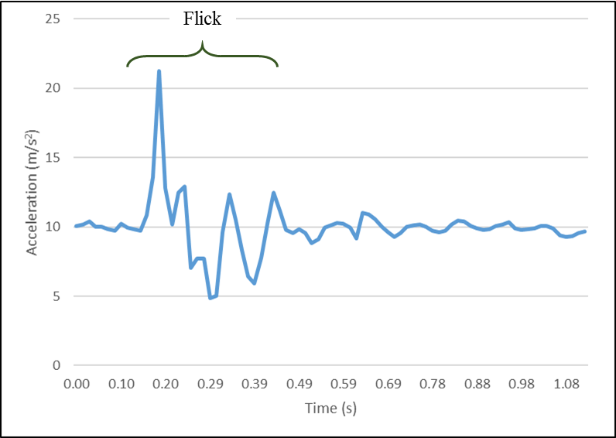

1. Left flick acceleration.

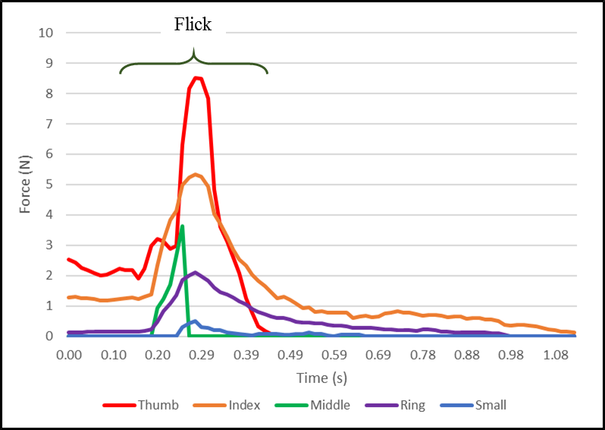

1. Left flick finger tips force.

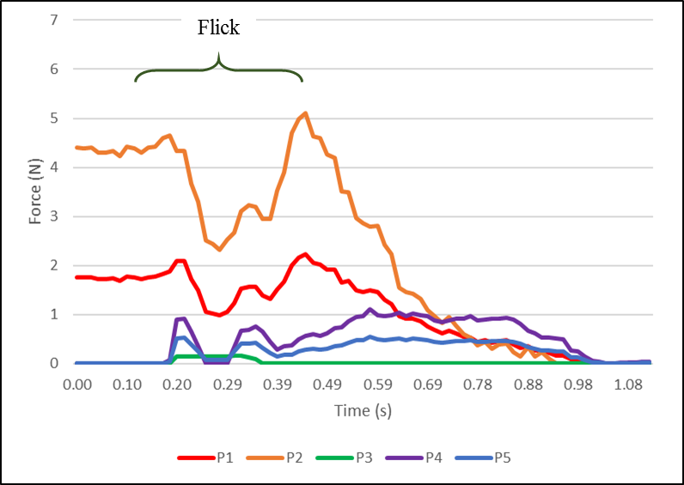

1. Left flick palm force.

# Discussion and Conclusions

A sensorized glove capable of measuring movement and interaction forces of the hand during neck manipulation has been developed. The glove provides real-time force visual feedback to the user and the data collected can be used for teaching and training. A performance evaluation of the two different types of force sensors incorporated into the glove design showed a total error of 0.84 Newtons or less, which accounts for RMS accuracy, noise and drift. This is considered to be an acceptable error value, as the applied forces range between 0 and 9 Newtons. In the future, a wireless prototype will be developed.

The implementation results show that the glove is capable of detecting the main components of the maneuver in both the acceleration and the applied forces. Future work will focus on validating the glove when used for skills assessment, i.e., when comparing the performance of novices and experts. This will allow for the construction of a database of parameters for the different manual maneuvers when performed by novice, intermediate and expert-level raters with the intention of facilitating competence in performance of this skill.

##### Acknowledgment

The authors would like to acknowledge Sheehan Abeysena for his contribution towards the preliminary design of the glove and components selection and Christopher Ward for his technical support with the electronics design.

##### References

1. M. Paciaroni, J. Bogousslavsky, “Cerebrovascular Complications of Neck Manipulation,” *European Neurology*, vol. 61, no. 2, pp. 112–118, February 2009.
2. S. J. Snodgrass, D. A. Rivett, V. J. Robertson, “Calibration of an instrumented treatment table for measuring manual therapy forces applied to the cervical spine,” *Manual Therapy*, vol. 13, no. 2, pp. 171–179, April 2008.
3. M-P. Harvey, S. Wynd, L. Richardson, C. Dugas, M. Descarreaux, “Learning Spinal Manipulation: A Comparison of Two Teaching Models,” *The Journal of Chiropractic Education*, vol. 25, no. 2, pp. 125–131, 201.